BRAINSTORM GRID by MBAconsultant.com
Welcome to your Brainstorm Grid. Use this document to gather the important information for your MBA application. Each table below links directly to a course in MBAconsultant.com. Save this file to your desktop, because we’ll refer to it when writing essays in the school courses and when answering video interview questions.

GOALS: SHORT, ALTERNATIVE, LONG
Instructions | What are your short-term post-MBA, alternative, and long term goals? Specify your target title, company/companies, industry, and geography.
Example | Short term, I’ll join a global FMCG company such as Unilever in an Operations role on the East Coast of the US.  Alternatively, I’ll continue to work in my current role at BCG and specialize in consulting for FMCG clients in the US.  Long term, I’ll start my own nutrition and health consultancy back home in Poland.
Short Term Goal:

Alternative Goal:

Long Term Goal:

GOALS: MY “WHY”
Instructions | Tell a story that demonstrates why you want to pursue the goals above. We recommend including a strong mission statement.
Example | Growing up, I spent many evenings in the kitchen with my mother, learning traditional recipes and the benefits of eating organic, whole foods. Her teachings inspired me to prioritize healthy eating, especially during the pandemic. In 2020, almost 40% of the adult global population was overweight. By making healthier food choices, I believe this figure could be significantly reduced. My mission is to make healthy food the rule, not the exception. I’ll improve people’s access to healthy food in developing markets.
Your ‘Why’:

GOALS: NOW UNTIL MBA
Instructions | If you plan to leave your current role more than 3 months before the MBA, what do you plan to do between leaving your role and the start of the program?
Example | I will develop my entrepreneurial idea. I plan to attend the International Conference on Clinical Nutrition & Dietary Lifestyle in LA to network with nutrition consultants and understand different business models. I will also take the Coursera course “Entrepreneurship and Innovation” to prepare for the MBA.
Goal now until MBA:

EXPERIENCE: LEADERSHIP
Instructions | Describe your leadership stories. What challenges did you face? What role did you play? How did you influence the behavior of others? What was the result?
Example | At Huawei, I navigated a power imbalance between the sales and technical team. So I met the teams separately and built trust by learning their responsibilities and communicating between them. Relations improved drastically and customers were given more reasonable deadlines and expectations.
Story 1:

Story 2:

Story 3:

EXPERIENCE: TRAUMA
Instructions | What personal or professional trauma have you faced? Did you have to make a difficult decision? How did you rise to the challenge? What did you learn? How has this experience shaped your values and motivations?
Example | I was diagnosed with scoliosis when I was 15. This has caused severe, even disabling pain and fatigue throughout my life and led to academic challenges. But through physiotherapy, back braces, and the support of my family, I persevered through treatment. This is a key reason why I entered the healthcare technology industry, where I work in regulatory compliance for medical innovations.
Story 1:

Story 2:

Story 3:

EXPERIENCE: ACHIEVEMENT
Instructions | What are your key achievements? Especially obstacles overcome, qualifications, projects or certificates achieved or relationships built. How were these earned and why were they meaningful to you?
Example | When I tried to convince my team at KPMG to adopt a new workflow to verify each other’s work, they resisted. So, I led by example by sharing my work with others first, reassured them that workflows would be kept within the confines of our team, and fostered a culture of trust between colleagues. Gradually, this workflow became commonplace in our team, and our cycle time fell from 28 to 15 days. I learned a lot about change management and organizational restructuring.
Story 1:

Story 2:

Story 3:

EXPERIENCE: FAILURE
Instructions | Discuss a time when you failed. Whom did you let down? How did they react? What did you learn and what could you have done differently?
Example | As a consultant, a pushy client threatened to cancel their contract. I agreed to their terms but ended up putting pressure on the servicing team to meet their demands. Later, in a different project, a colleague showed me a different communication style and taught me to be more assertive. I implemented this feedback in future projects. Next year, I was promoted and appreciated for my skill to manage client expectations.
Story 1:

Story 2:

Story 3:

EXPERIENCE: TEAMWORK
Instructions | Describe a time you worked in a tight team or community. What challenge did you overcome together? What part did you play? What did you learn from your team/community? Would you have done things differently?
Example | I was in a 4-man crew participating in the British junior national rowing championship 2 km race in 2017. 30 meters before the finish line, my friend George made a mistake. We lost, and the team was furious at him. So, I calmed the others down and put my arm around George’s shoulder. The following year, George put in an outstanding performance and we won. I learned that people perform better when their failures are met with empathy rather than frustration. I apply this to my work at Bain when training new analysts.
Story 1:

Story 2:

Story 3:

EXPERIENCE: DIVERSITY, EQUITY, INCLUSION
Instructions | How have you demonstrated a commitment to diversity and inclusive leadership in your life? How has your identity, international experience, or background influenced your life?
Example | I was born into a Catholic family. So, when my mother remarried a Jewish man, I was initially reluctant to take part in Jewish family traditions, feeling as if I was betraying my own religion. But at our first big family gathering, when we all shared food and stories, my perspective on religious beliefs and cultures broadened. I have since carried this inclusive group mindset with me and cultivated an adaptive mentorship style to connect on a personal level with people from diverse backgrounds.
Story 1:

Story 2:

Story 3:

EMPLOYMENT: JOB DESCRIPTION
Instructions | Describe your job responsibilities: your nature of work, day-to-day role, and if applicable, teams, clients/projects, budgets, and projects managed.
Example | I am an Associate at BCG, where I provide consulting services to clients in a variety of industries. My project responsibilities include analysis, presenting my findings, and implementation of suggestions. Last year, I delivered 4 successful projects, including an agile €20m+ IT project at a state-owned bank, saving them $5m+ in procurement costs.
Current Role:

Previous Role 1:

Previous Role 2:

EMPLOYMENT: REASON FOR LEAVING
Instructions | Explain briefly why you left this role.
Example | I was contacted by a recruiter and offered an opportunity that would increase my salary and leadership responsibilities, which I accepted.
Current Role: Not Applicable / Still Working

Previous Role 1:

Previous Role 2:

EMPLOYMENT: GAPS
Instructions | Explain any gaps of 3 months or more in your employment or education history.
Example | After graduating from Chicago Data Academy in December 2017, I signed an employment offer with Pfizer within 6 weeks. My start date was April 2018, so I worked part-time as a TA at the Data Academy until then. I developed my management and networking skills, and also brushed up on my data science knowledge and contributed to curriculum development.
Gap 1:

Gap 2:

SCHOOL RESEARCH
Instructions | List the classes and extracurriculars that attract you to each of your target schools.
Example | Classes: I spoke to CBS alumni Tracy Parker (CBS ‘16) and Mahmoud Amir (CBS ‘21). They recommended that I take interdisciplinary courses in visual arts administration, especially “The Future of Arts Administration” and “Art Innovation”. I am also interested in the “Artificial Intelligence for Business Transformation” and “Organizational Change” classes. I will also participate in the Center of Global Brand Leadership and work on research papers and the Marketing Innovation Case Competition to widen my academic horizons.  Extracurriculars: I want to join the CBS Arts Society where I will help organize visual arts events, in partnership with diverse cultural institutions and students, industry leaders, and stakeholders. I will share my prior experience in event management at the Phillips Collection and as part of the DC Commission on the Arts and Humanities Council with my peers in the club.
School 1
- Classes:
- Extracurriculars:
School 2:
- Classes:
- Extracurriculars:
School 3:
- Classes:
- Extracurriculars:
School 4:
- Classes:
- Extracurriculars:
School 5:
- Classes:
- Extracurriculars:
School 6:
- Classes:
- Extracurriculars:

NEXT: SCHOOL ESSAYS
  Columbia |   INSEAD
  Wharton |   Cambridge Judge
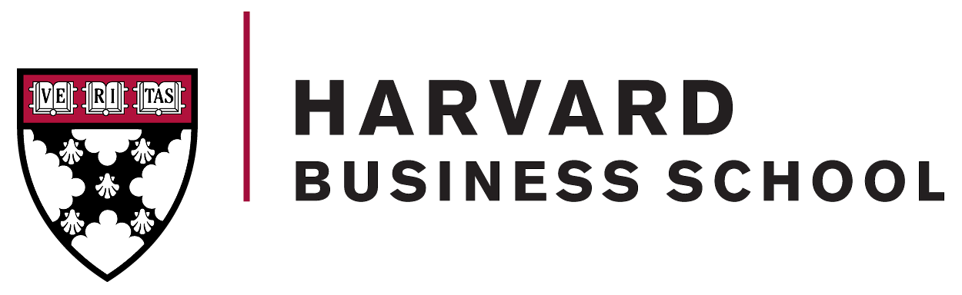  HBS |   Cornell Johnson
  Stanford GSB |   Duke Fuqua
  MIT Sloan |   Chicago Booth
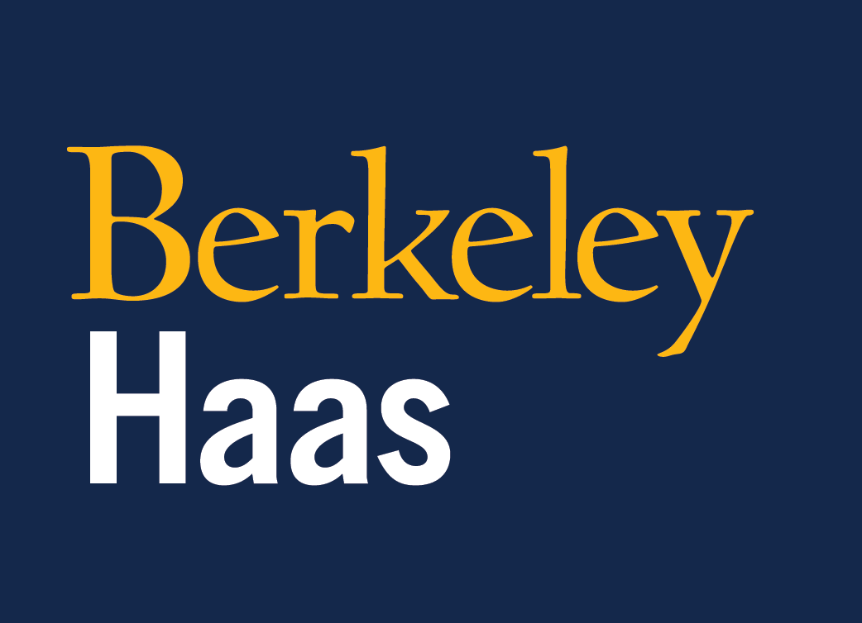  Berkeley Haas |   Oxford Saïd
  LBS | 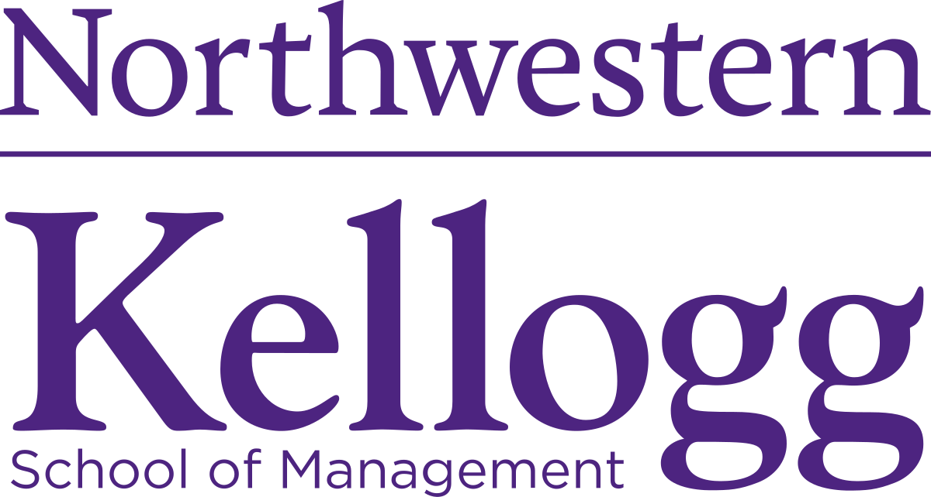  Northwestern Kellogg
  NYU Stern | More Coming Soon…

